**Topics: Descriptive Statistics and Probability**

1. Look at the data given below. Plot the data, find the outliers and find out $μ, σ, σ^{2}$

|  |  |
| --- | --- |
| **Name of company** | **Measure X** |
| Allied Signal | 24.23% |
| Bankers Trust | 25.53% |
| General Mills | 25.41% |
| ITT Industries | 24.14% |
| J.P.Morgan & Co. | 29.62% |
| Lehman Brothers | 28.25% |
| Marriott | 25.81% |
| MCI | 24.39% |
| Merrill Lynch | 40.26% |
| Microsoft | 32.95% |
| Morgan Stanley | 91.36% |
| Sun Microsystems | 25.99% |
| Travelers | 39.42% |
| US Airways | 26.71% |
| Warner-Lambert | 35.00% |

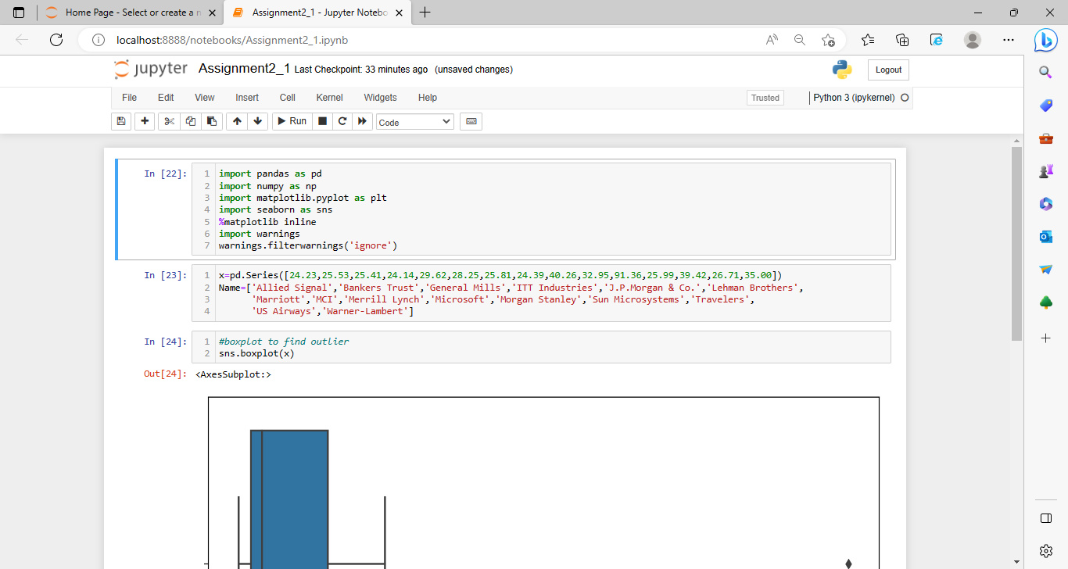

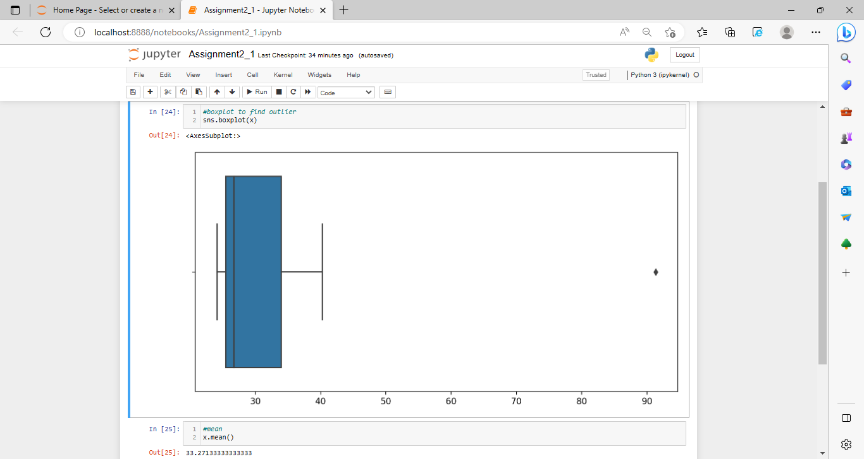

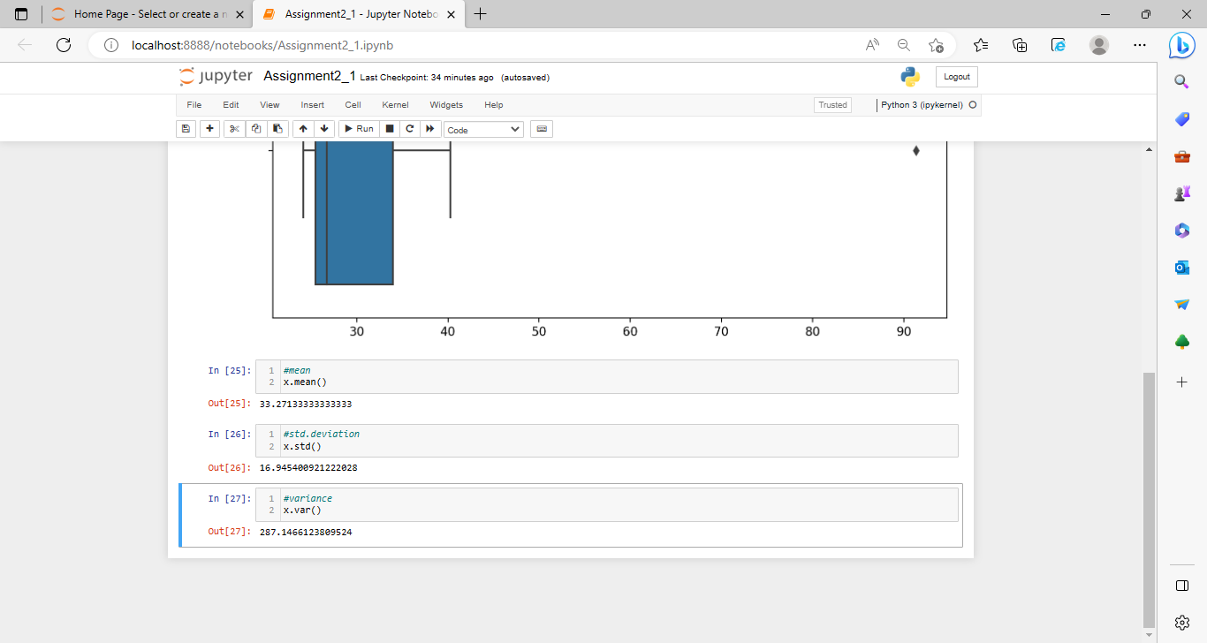



Answer the following three questions based on the box-plot above.

1. What is inter-quartile range of this dataset? (please approximate the numbers) In one line, explain what this value implies.

Inter-quartile range=q3-q1

=12-5=7

the interquartile range gives you the range of the middle half of a data set.

1. What can we say about the skewness of this dataset?

The skewness of this dataset is positive.

1. If it was found that the data point with the value 25 is actually 2.5, how would the new box-plot be affected?

In that case there would be no Outliers on the given dataset because of the outlier

the data had positive skewness it will reduce and the data will normal distributed



Answer the following three questions based on the histogram above.

1. Where would the mode of this dataset lie?

Ans. The mode of this data set lie in between 5 to 10 and approximately between 4 to 8 .

1. Comment on the skewness of the dataset.

Ans. Right-Skewed. Mean>Median>Mode

1. Suppose that the above histogram and the box-plot in question 2 are plotted for the same dataset. Explain how these graphs complement each other in providing information about any dataset.

Ans. They both are right-skewed and both have outliers the median can be easily visualized

in box plot where as in histogram mode is more visible.

1. AT&T was running commercials in 1990 aimed at luring back customers who had switched to one of the other long-distance phone service providers. One such commercial shows a businessman trying to reach Phoenix and mistakenly getting Fiji, where a half-naked native on a beach responds incomprehensibly in Polynesian. When asked about this advertisement, AT&T admitted that the portrayed incident did not actually take place but added that this was an enactment of something that “could happen.” Suppose that one in 200 long-distance telephone calls is misdirected. What is the probability that at least one in five attempted telephone calls reaches the wrong number? (Assume independence of attempts.

Ans.200 long distance telephone calls is misdirected

Probability of calls misdirecting P=1/200

Probability of call not Misdirecting = 1-1/200 = 199/200

The probability for at least one in five attempted telephone calls reaches the wrong number

Number of Calls = 5

n = 5

p = 1/200

q = 199/200

P(x) = at least one in five attempted telephone calls reaches the wrong number

P(x) = ⁿCₓ pˣ qⁿ⁻ˣ P(x) = (nCx) (p^x) (q^n-x) # nCr = n! / r! * (n - r)!

P(1) = (5C1) (1/200)^1 (199/200)^5-1 P(1) = 0.0245037

1. Returns on a certain business venture, to the nearest $1,000, are known to follow the following probability distribution

|  |  |
| --- | --- |
| X | P(x) |
| -2,000 | 0.1 |
| -1,000 | 0.1 |
| 0 | 0.2 |
| 1000 | 0.2 |
| 2000 | 0.3 |
| 3000 | 0.1 |

1. What is the most likely monetary outcome of the business venture?

As the probability (0.3) is more for 2000$ than others that’s why the most likely monetary outcome of the business venture is 2000$

1. Is the venture likely to be successful? Explain

Venture is successful if X is positive

Hence is X = 1000,2000,3000

Probability is 0.2+0.3+0.1=0.6

As 0.6 > 0.5 the venture is likely to be successful

1. What is the long-term average earning of business ventures of this kind? Explain

E(X)=∑X . P(X)

=(-2000*0.1)+(-1000*0.1)+0+(1000*0.2)+(2000*0.3)+(3000*0.1)

=800$

Means the long term avg. earning of business will be 800$

1. What is the good measure of the risk involved in a venture of this kind? Compute this measure

Var (X) = E(X²)  - { E(X) }²

=   2800000 -   800²

= **2160000**  ( Quite High)

SD = √Var  ≈ **$ 1470**

As **Variability is Quite high**  hence **Risk is hig**h